Dicas do documento referente ao IBM STERNLING CONNECT:DIRECT

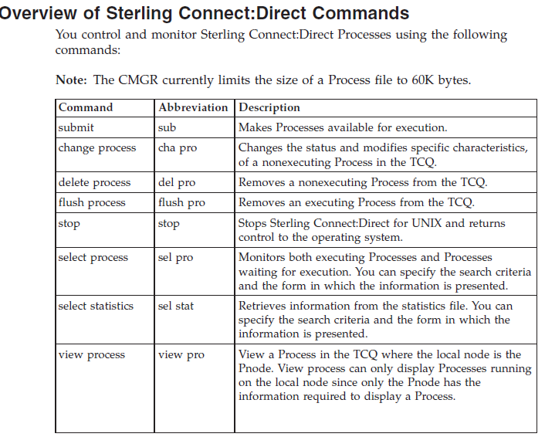

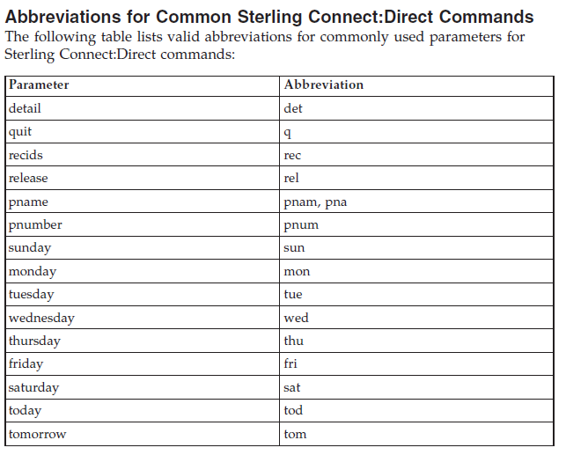

Códigos de Retorno:

Following are the valid record ID values:

|  |  |
| --- | --- |
| APSM | License Management failure generated. |
| CHGP | The change process command issued. |
| CRHT | Copyright statement. |
| COAC | Listen connection enabled for either API or a remote node. |
| CSPA | Sterling Connect:Direct Secure Plus failure generated. |
| CSTP | Child Process stopped. |
| CTRC | Copy termination record. |
| CTRM | Child Process terminated. |
| CUKN | Child Process unknown status. |
| CXIT | Child Process exited. |
| DELP | The delete Process command issued. |
| FLSP | The flush Process command issued. |
| FMRV | Error occurred in function management. information receive operation. |
| FMSD | Error occurred in function management. information send operation. |
| GPRC | Error occurred while getting Process. |
| IFED | The if statement ended. |
| LSST | The record ID of a step on the local node. |
| LIEX | License expired. |
| LWEX | License expires within 14 days. |
| NINF | Sterling Connect:Direct information generated at startup. |
| NMOP | Network map file opened. |
| NMPR | The network map is updated through Sterling Connect:Direct Browser User Interface, Sterling Control Center Console, or KQV Interface. |
| NUIC | Initialization complete. |
| NUIS | Initialization started. |
| NUTC | Termination completed. |
| NUTS | Termination started. |
| PERR | Process error. |
| PFLS | Process flushed. |
| PRED | Process ended. |
| PRIN | Process interrupted. |
| PSAV | Process saved. |
| PSTR | Process started. |
| QCEX | A Process moved from another queue to the EXEC queue. |
| QCWA | A Process moved from another queue to the WAIT queue. |
| QCTI | A Process moved from another queue to the TIMER queue. |
| QCHO | A Process moved from another queue to the HOLD queue. |
| RJED | The run job ended. |
| RNCF | Remote node connection failed. |
| RSST | The record ID of a step on the remote node. |
| RTED | The run task ended. |
| RTSY | Run task restarted. Resyncing with run task that was executing. |
| SBED | The submit ended. |
| SELP | The select Process command issued. |
| SELS | The select statistics command issued. |
| SEND | Session ended. |
| SERR | System error. |
| SFSZ | Size of the file submitted. |
| SGON | User signed on using KQV Interface or Command Line Interface. |
| SHUD | Shutdown occurred. |
| SIGC | Signal caught. |
| SSTR | Session start. |
| STOP | The stop command issued. |
| SUBP | The submit command issued. |
| TRAC | The trace command issued. |
| TZDI | The time zone of the local node represented as the difference in seconds between the time at the local node and the Coordinated Universal Time. |
| UNKN | Unknown command issued. |
| USEC | Security check for user ID failed. |
| USMG | Sterling Connect:Direct is shutting down. |
| XCMM | Command manager (CMGR) messages. |
| XCPR | Copy receive. |
| XCPS | Copy send. |
| XIPT | Communication errors. |
| XLKL | Low-level TCQ record locking errors. |
| XMSG | Message sent to user exit. |
| XPAE | Parsing error occurred when a Process or command was submitted. |
| XPAM | Parsing error occurred when a Process or command was submitted. |
| XPMC | Process manager (PMGR) connection error messages.XPML |
| XPMP | PMGR error messages when checking permission on the Sterling Connect:Direct programs. |
| XPMR | PMGR RPC and miscellaneous error messages. |
| XPMT | PMGR termination error messages. |
| XRPM | Run task or run job error messages. |
| XRRF | Relative record file access error messages. File structure is use for TCQ. |
| XSMG | Session manager (SMGR) error messages. |
| XSQF | File access error messages. |
| XSTA | User exit program started. |
| XTQG | A single TCQ error message group. |
| XTQZ | A single TCQ error message group. |

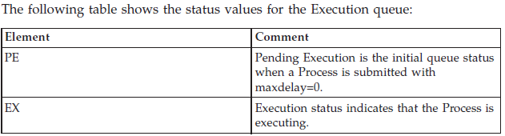

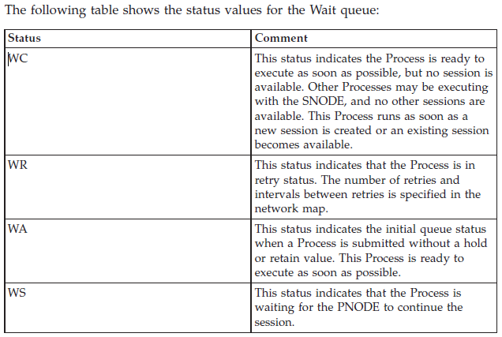

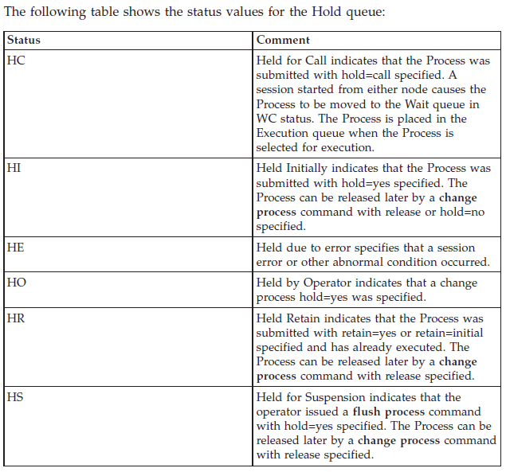

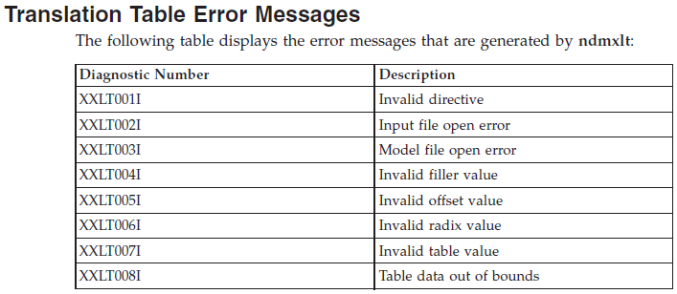

The CLI passes the resp_buffer to

AWK for parsing. Valid values

include:

|  |  |
| --- | --- |
| ADMN | Sterling Connect:Direct administrator name |
| ADPH | Sterling Connect:Direct administrator phone number |
| CCOD | Completion code |
| CKPT | Checkpoint |
| CLAS | Class |
| DBYW | Bytes written |
| DBYX | Bytes received |
| DCOD | Destination completion code |
| DDAY | Submit date |
| DDS1 | Destination disposition 1 |
| DDS2 | Destination disposition 2 |
| DDS3 | Destination disposition 3 |
| DESC | Sterling Connect:Direct administrator description |
| DFIL | Destination file |
| DMSG | Destination message ID |
| DNVL | Destination number of volumes |
| DRCW | Records written |
| DRUX | RUs received |
| DVOL | Destination volume array |
| ECMP | Extended compression ON or OFFFROM Copy sending node |
| LCCD | Local completion code |
| LCLP | Local IP address and port number |
| LKFL | Link fail |
| LMSG | Local message ID |
| LNOD | Local node |
| MSGI | Message |
| IDMSGT | Message text |
| MSST | Short text |
| OCCD | Other completion code |
| OERR | Other node in error |
| OMSG | Other message ID |
| PACC | PNODE account |
| PFIL | Process file |
| PNAM | Process name |
| PNOD | PNODE |
| PNUM | Process number |
| PPMN | PDS member name |
| PRTY | Priority |
| QUEU | Queue |
| RECC | Record category |
| RECI | Record ID |
| RETA | Retain Process |
| RMTP | Remote IP address and port number |
| RSTR | Process restarted |
| RUSZ | RU Size |
| SACC | SNODE account |
| SBID | Submitter node ID |
| SBND | Submitter node name |
| SBYR | Bytes read |
| SBYX | Bytes sent |
| SCMP | Standard compression |
| SCOD | Source completion code |
| SDDY | Schedule date |
| SDS1 | Source disposition 1 |
| SDS2 | Source disposition 1 |
| SDS2 | Source disposition 2 |
| SDS3 | Source disposition |
| 3SELA | Elapsed time of the event |
| SFIL | Source file |
| SMSG | Source message ID |
| SNAM | Step name |
| SSTA | Start time of the event |
| STAR | Start log date/time for Record |
| STAT | Process status |
| SNOD | SNODE |
| SNVL | Source number of volumes |
| SOPT | SYSOPTS record |
| SRCR | Records read |
| SRUX | RUs sent |
| STIM | Schedule time |
| STOP | Stop time of the event |
| SUBM | Submitter ID |
| SUBN | Submitter node |
| SUMM | Summary output selector |
| SVOL | Source volume array |
| TIME | Submit time |
| XLAT | Translation |